
CAREY HUT CHARITABLE TRUST
Carey Hall
Mistover Road
Wareham
BH20 4BY

CAREY HUT CHARITABLE TRUST
ANNUAL GENERAL MEETING
Monday 14th September 2026
7.00 pm Carey Hall
AGENDA

- Welcome and introductions
- Apologies
- Minutes of 2025 AGM
- Matters arising
- Trustees’ report given by Chair
- Treasurer’s report
- Booking Secretary’s report
- Election of committee

  - Chair, currently Marian Cotton
nominated as Chair Marian Cotton
proposed seconded
  - Deputy Chair, currently vacant
  - Treasurer, currently Mike Pollard, Julie Bradshaw
nominated as Treasurer, Mike Pollard, Julie Bradshaw
proposed seconded
  - Booking Secretary, currently Sue Dean
nominated as Booking Secretary, Sue Dean
proposed seconded
  - Secretary, currently Julie Bradshaw
nominated as Secretary Julie Bradshaw
proposed seconded
  - Book-keeper, currently Laura Leach
nominated as Book-keeper, Laura Leach
proposed seconded
  - Committee members in addition to those above, currently
(Sue Dean represents Sandford and Wareham WI and Wareham Town Council)
Sue Reeves, local resident and Carey Short Mat Bowls
Richard Weaver represents Wareham Lions
Les Wright represents Purbeck Association of the National Trust
Leon Somerville was coopted during the year but has handed over his contribution on social media to Theo Street
nominated Sue Reeves, Richard Weaver, Les Wright, Theo Street
proposed seconded
  - Trustees, currently
Marian Cotton, local resident;
Julie Bradshaw, local resident;
Sue Reeves, Carey Short Mat Bowls;
Richard Weaver. Lions.
Nominated Marian Cotton, Julie Bradshaw, Sue Reeves, Richard Weaver.
proposed seconded
- Priorities for the year 2026/27.
9.1 Recruiting at least one more Trustee
9.2 Acoustic panels
9.3 Fundraising
9.4 Consolidating financial procedures
- A.O.B.
- Date of 2027 AGM to be decided at committee meeting 2027

Appendix: minutes of 2025 AGM.
Appendices to follow: accounts 2025/2026, Trustees’ Report

Carey Hut Charitable Trust AGM 2025 Minutes
Meeting 08.09.2025
Present: Helen Geach, Trustee, Treasurer, Carey Crafters; Marian Cotton, Trustee, Chair, local resident; Julie Bradshaw, Trustee, Secretary, Short Mat Bowls; Sue Dean, Booking Secretary, Committee, Sandford and Wareham WI; Sue Reeves, Committee, Short Mat Bowls; Rhonda Walker, Wareham Visually Impaired and Blind Club; Harparkash Rispin, Wareham Creative Textiles; Sophia Wright, Purbeck Association of the National Trust; Frances Usler, local resident; Angela Joynson, local resident; Fred Evens, local resident; Beryl Ezzard, Friends of Wareham Railway Station, Irina Song, Dorset Art Classes; Janice Dutton.

- Welcome and introductions
- Apologies
Apologies were received from Doreen Cleaton; Jayne Critchlow, Poole Heart Support Group; Ray and Angela Jones; Mariel Harrison, Sing & Sign.

- Minutes of 2024 AGM
Agreed

- Matters arising
4.1 Bug houses had been installed and an entry made in the Britain In Bloom competition. The Men’s Shed built a bug hotel and bug boxes. Children from TOPS nursery built a bug hotel.
4.2 Spending priorities 2024-2025, the following had been purchased: cooker and fridge, emergency lighting check, cage for the outside heating unit, floor cleaning. The coving had been booked for the August 2 week closure because the strong smell of the glue needs at least one day to go off.

- Chair’s report
Marian commended the strong, enthusiastic committee whose members shared the opening and closing of the hall for one-off and new, regular hirers and were ready to muck in with all the jobs.
Marian made a presentation to Helen to thank her for all her work as Booking Secretary from which she resigned during the year and Treasurer, committee member and trustee.
During the 2 week closure, the following work was complete: 5 year electrical installation check, 1 year emergency lighting check with some new lights installed; new water heater / urn, curtains washed and rehung, chair upholstery cleaned, new coving fixed in main hall, lobby and toilets, new notice board hung, kitchen painted, front door re-painted.
Next year it is planned to close the hall for one week in August to have the main hall decorated including painting the wooden panels above the entrance door in order to make the hall lighter.

- Treasurer’s report
Current account £3,607
Savings account £33,523 which includes £9,000 grant for the solar panels.
The solar panels cost £10,500; we could not apply for a larger grant from the National Lottery Community Fund as we had been awarded a grant last year. The difference will funded by proceeds from the Bingo afternoons. Many thanks to the Bingo group.
Helen had been in dispute with Culligans, the supplier of the water heater / urn. Our previous machine, which was leased, became unfit for use and after some delay Culligans provided a new model for us to try out and, if we were satisfied, to buy instead of leasing. As soon as it was installed we realised that the new machine was unsuitable because it was impossible to fit a teapot under the spout. We informed Culligans and asked for an alternative but nothing was forthcoming. We bought a machine from another supplier and eventually Culligans agreed to release us from their contract.

- Booking secretary’s report (Sue Dean)
There are over 20 weekday bookings in a month.
Frances who had been booking Monday mornings was stopping because of ill health and there were already 2 enquiries to take over that slot.
We don’t take regular bookings for the weekend to leave the hall free for local people who wish to organise an event. We have an arrangement with a bouncy castle supplier so that people can make an inclusive booking. More weekend bookings are welcome.
The minimum booking charge is £20 weekdays and £25 weekends which includes use of the kitchen and car park. The ATC booked the hall because it gave them the space they needed for drill practice.

- Election of committee
The committee was sad to lose John Smith, one founder member of the hall. Also,Harparkash reported the recent death of Pam Coffen, another founder member.
Officers
  - Chair, currently Marian Cotton
Marian is willing to stand
proposed Helen, seconded Janice, elected
  - Deputy Chair, currently vacant
no nominations, remains vacant
  - Treasurer, currently Helen Geach
Helen is resigning due to ill health from 13th September
no nominations
Julie and Marian to handle Treasurer’s duties in interim
  - Booking Secretary
Helen resigned as Booking Secretary during the year (27.01.25) and Sue Dean took over
Sue Dean is willing to stand
proposed Julie, seconded Marian, elected
  - Secretary, currently Julie Bradshaw
Julie is willing to stand
proposed Marian, seconded Sue Dean, elected
  - Committee members in addition to those above, currently Doreen Cleaton, Angela Jones, Ray Jones, Wareham Disabled Club;
Sue Reeves, Wareham Short Mat Bowls
no other nominations
proposed Marian, seconded Helen, elected
  - Trustees, currently Helen, Marian, Julie
Helen is resigning from 13.09.25
Trustees nominated: Marian, Julie, Sue Reeves
Proposed Marian, seconded Helen, elected

9. Priorities for the year 2025/26
9.1 Managing the handover from Helen
An accountant will be involved in the book keeping
9.2 Recruiting at least one more Trustee
All those present asked to consider if they knew of anyone suitable and willing
9.3 Building the committee
As 9.2
9.4 Solar panels
The solar panels are on the roof.
We had noted from meter readings how much electricity was used and from bookings at what time of day (using June 2025 for the sample), given the information to the solar panel companies and obtained 3 quotes.
We had used H2Eco because the prices were similar and H2Eco, having installed the air-to-air heating, was familiar with the electrical installation. We will be monitoring the use of electricity and the input of the solar panels over the seasons to assess the value of having a battery added to the system. It is noted that on a very hot day less electricity is generated by the solar panels than on a less hot, bright day.
9.5 Fundraising
In 2024/25 Marian organised vinyl nights to raise money for the Mayor’s charity, the Air Training Cadets. Keith provides the music, 60’s, 70’s and 80’s records, someone else provides the disco lights, entry is £5 and people bring their own food and drink. There is a raffle. This year Marian will organise 4 vinyl nights, 3 to raise money for the hall and one for charity.
We have been disappointed by the response to table top sales. We would benefit from an extra person on the committee to take on the responsibility of publicity.
We run 2 community parties a year, not to raise funds but they should build the profile of the hall. For the first time we will have a Christmas party which will be on Sunday 7th December. Entry is free, there is entertainment and people bring their own refreshment.
Helen reported that the Carey Crafters sales also had poor attendance.
It was suggested that we ask at the station whether we could display a poster and flyers in the booking office.
We welcome new and innovative ideas for fundraising (or old ones, if they work).

10. Any other business
The committee was thanked.
The garden at the front is a great improvement.
Frances ran a group at the hall some years ago and now finds the hall is much better.
11. The date of the 2026 AGM will be decided at a committee meeting in 2026. The meeting closed at 8pm.

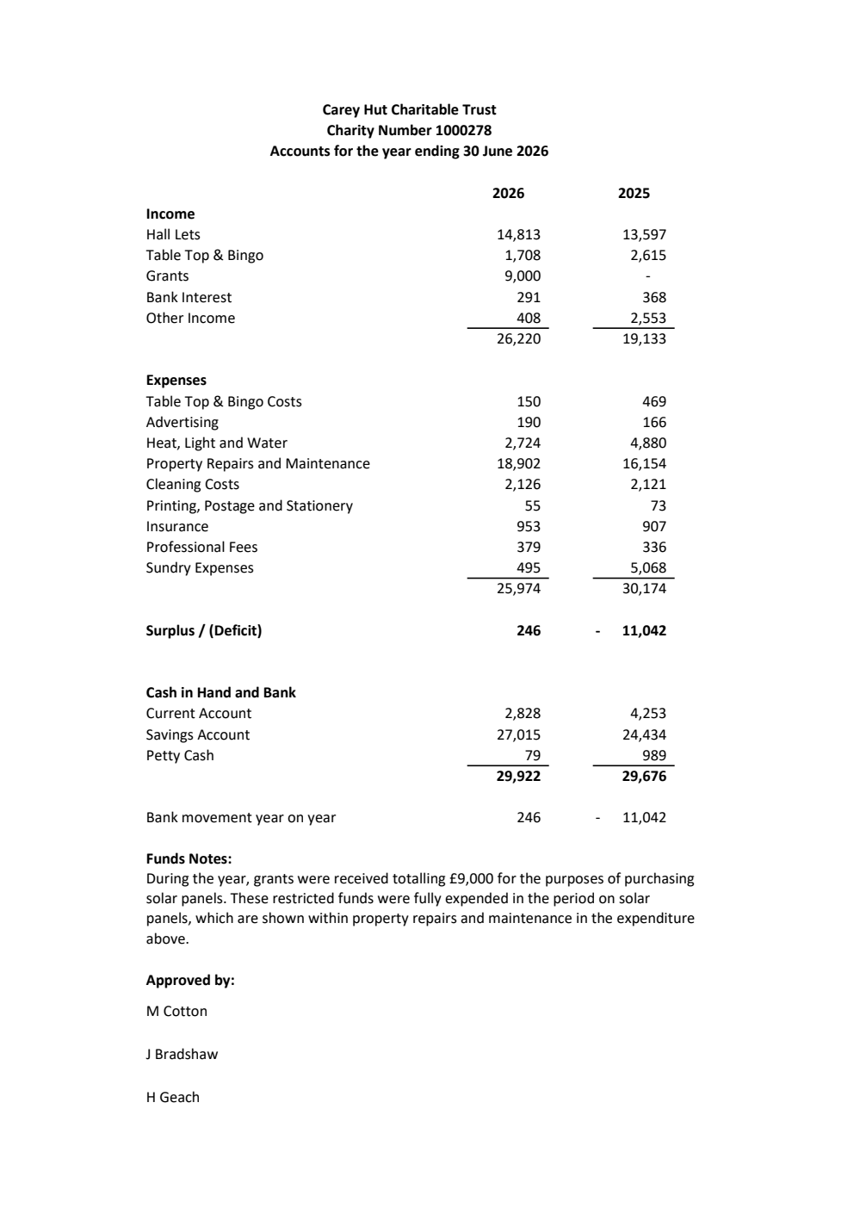
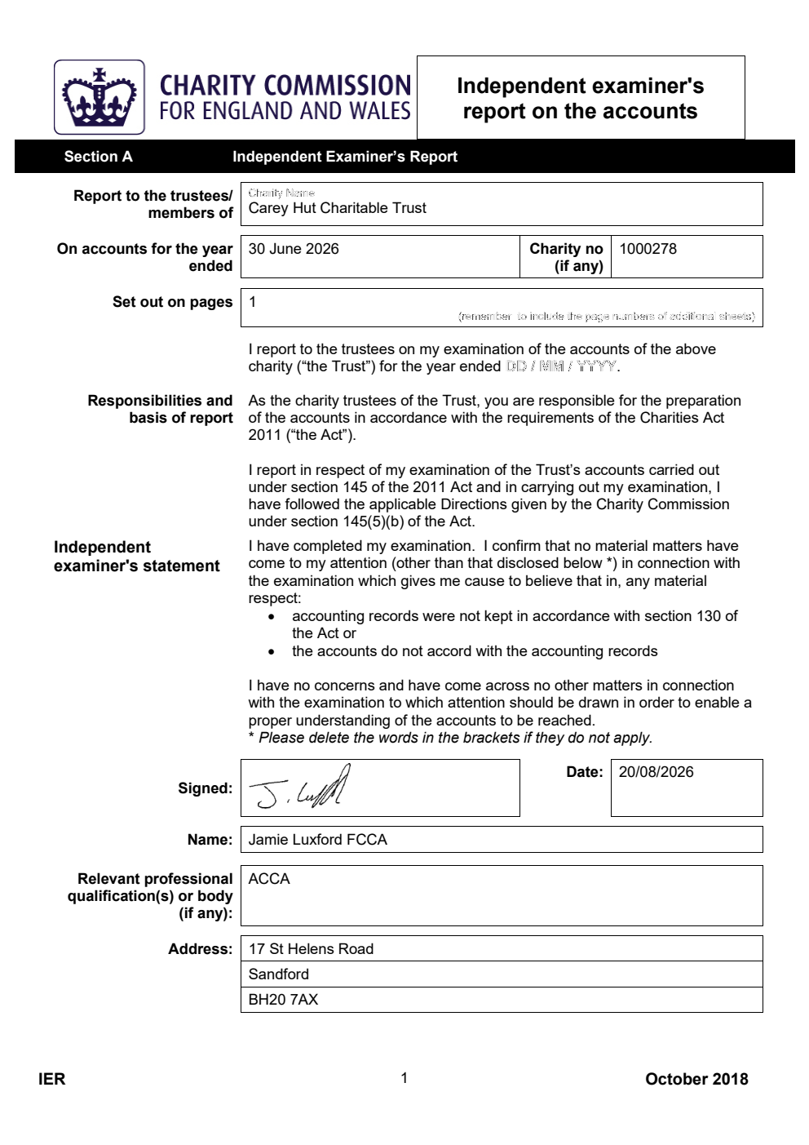



Trustees’ Annual Report for the period

From 1st July 2025 To 30th June 2026

Charity name: Carey Hut Charitable Trust

Charity registration number: 1000278

Objectives and Activities

Carey Hall is held upon trust by the charity for the purposes of a village hall for the use of the inhabitants of the Parish of Wareham Lady St Mary, Dorset, without distinction of political, religious or other opinions including use for meetings, lectures and classes and for other forms of recreation and leisure time occupation with the object of improving the conditions of life for the said inhabitants.
.
Carey Hall is hired out on a regular basis to the following groups:
- Short mat bowls
- U3A Singing
- Wareham Disabled Club
- Creative Textiles
- Sandford and Wareham WI
- Carey Crafters
- Purbeck Association National Trust
- Wareham Visually Impaired and Blind Club
Keep Fit With Karen
Pilates
Bingo
Keep Fit (Sarah)
Swim Exercise
Karate
Sing & Sign
Poole Heart Support Group
Carey Hall is used as a polling station.
It is hired by local people for parties, wakes and wedding receptions.

CHCT’s purpose is beneficial in that Carey Hall provides a meeting place for the community.
CHCT’s purpose benefits the community by providing a warm / air conditioned, welcoming, well-lit, accessible, safe space for a great variety of sociable activities at an acceptable cost to the users.
The Trustees will keep the hall financially viable and have regard to environmental factors while maintaining and improving the hall’s attractiveness to its users.

Additional information (optional)
You may choose to include further statements where relevant about:
Policy on grant making | n/a
Policy on social investment including program related investment | n/a
Contribution made by volunteers | CHCT has no employees. The Trustees and the operational committee members are volunteers.

Achievements and Performance

Achievements 2025-2026
BOOKING
Every weekday day time session is booked at least once a month.
MAINTENANCE
We used a two week closedown in August to paint the ceiling and walls in the kitchen and clean the cupboards. The curtains were taken down, washed, ironed and rehung. The upholstery of the chairs was cleaned. A coat of paint was put on the main outside door. The 5 year electrical check was done and necessary work completed.
A concrete path was made from the fire exit near the electrical cupboard to the tarmac of the car park. A portable ramp was purchased for the kerb at the end of the path.
Window frames were revarnished.
We replaced the urn, a faulty closer on the kitchen door and the glass in the hall doors with safety glass.
An electricity supply was introduced to the second water heater in the Ladies toilet.
We bought and hung a new cork notice board.
We replaced the email address, hirecareyhall, with careyhallwareham to which Julie and Sue Dean have access.
FUNDRAISING
We reduced the frequency of the table top sales to quarterly in the hope of attracting more sellers and buyers.
Good attendance at Bingo yielded revenue for hall maintenance.
We held a quiz to raise funds for acoustic panels.
PUBLICITY
Business cards, new facebook page and Instagram entry.
COMMUNITY
We held 2 community parties with an entertainer. Guests provided their own food and donations.
The hall was well used by local people for children’s and family parties.
We continued the monthly update to regular hirers with news of the hall as well as reminders about conditions of use.
CHARITABLE STATUS
We formulated financial procedures sharing the duties out between the booking secretary, secretary, treasurer and booking clerk. This seemed to work well with the booking secretary raising invoices for the hirers, the secretary monitoring payments and paying invoices, the booking clerk keeping an eye on the detail of the transactions and the treasurer keeping a more general financial control and producing an easily read, monthly report. Having financial procedures in place will make conversion of the charitable status easier. In addition, the Chair holds petty cash and keeps separate account.

OTHER
Water trays have been introduced in the wildlife area. The dead hedge has been rlaid as a habitat for hedgehogs and other wildlife. The broken wildlife sign was replaced.

Additional information (optional)
You may choose to include further statements where relevant about:
Objectives 2024/25:  Community party to bring local community into the hall  Improve the immediate surroundings of the hall  To develop the wildlife area  To maintain a reasonable temperature for hirers | Achievements:  40-50 people attended both parties.  The grass at the front of the hall was regularly mown. Flowers grew from seeds in the two small beds alongside the new path.  Brambles etc. were cleared from the bed near the disabled bus parking place.  Slow worms were seen under the reptile mats. Paths were cut through unmown grass. It was visited by a judge from South and Southeast Britain In Bloom  After a brief interruption when the air cooling did not work, we were able to cool the hall on days when the temperature outside was above 23 which allowed sessions which might otherwise have had to be cancelled to continue.
Objectives 2024/25:  To maintain / increase the level of hiring  Fundraising  Publicity | Fundraising  The week day bookings stayed steady in 2026 at 46 out of 60 sessions per 4 weeks. As some groups meet once a month, it is not always possible to fill the same session on other weeks in the month. Weekend bookings are irregular so that the hall is available for local people but the committee decided that we would hire the hall for one Sunday evening a month to a church group.  As the monthly table top sales were not attracting sufficient interest, we decided to limit them to quarterly.  Attendance at Bingo on Friday afternoons was good providing revenue for hall maintenance.  Carey Hall was publicised on Wareham community facebook page as well as its own facebook page and website.  Posts appeared in the Whats On feature in the Gazette.  Events appeared in the Love It Local events feature.
Objectives 2024/25  To aim to increase the reserve to at least £25,000, initially £22,000 by the end of June 2025. | Investment  The reserve is held in a Barclays savings account which gives little interest but has minimal risk. The balance on 13.06.26 was £26,215.

Financial Review

Review of the charity’s financial position at the end of the period | The charity was in a healthy financial position at the end of June 2026. The closed period this year is 24-28 August. Including Bingo in the Spotlight feature in the Gazette brought in some extra punters.
Statement explaining the policy for holding reserves stating why they are held | We now have a Reserves Policy. The reason for holding reserves are 1) to cover expenses if we should need to close the hall for safety reasons and lost the hire income as a result and 2) to cover the cost of maintenance work arising from general wear and tear on a 30 year old building.
Amount of reserves held | £25,000
Reasons for holding zero reserves | n/a
Details of fund materially in deficit | n/a
Explanation of any uncertainties about the charity continuing as a going concern | Insurance cover including solar panels  building £818,548  contents £11,812  defibrillator £5,000  loss of revenue £35,000

Additional information (optional)
You may choose to include further statements where relevant about:
The charity’s principal sources of funds (including any fundraising) | Hall lets  Bingo afternoons
Investment policy and objectives including any social investment policy adopted | n/a
A description of the principal risks facing the charity | Anything which would prevent the hall being hired out. The cost of maintaining the building would continue without the income.

Structure, Governance and Management

Description of charity’s trusts:
Type of governing document  (trust deed, royal charter) | Trust deed
How is the charity constituted?  (e.g unincorporated association, CIO) | Charitable trust
Trustee selection methods including details of any constitutional provisions e.g. election to post or name of any person or body entitled to appoint one or more trustees | Trustees are elected at the Annual General Meeting. Each organisation which regularly hires the hall will be notified of the AGM. Each Trustee signs to accept and act in the trusts of the deed. Anyone who is bankrupt or has an arrangement with creditors is disqualified.

Additional information (optional)
You may choose to include further statements where relevant about:
Policies and procedures adopted for the induction and training of trustees | Each trustee is given the Trust Deeds and CC3 “The Essential Trustee What You Need To Know and What You Need To Do”.
The charity’s organisational structure and any wider network with which the charity works | The committee members, Chair, Vice-chair, Treasurer, Booking Secretary, Secretary are elected at the AGM.

Reference and Administrative details

Charity name | Carey Hut Charitable Trust
Other name the charity uses
Registered charity number | 1000278
Charity’s principal address | Carey Hall  Mistover Road  Wareham  BH20 4BY

 | Names of the charity trustees who manage the charity
 |  |  | Trustee name | Office (if any) | Dates acted if not for whole year | Name of person (or body) entitled to appoint trustee (if any)
 |  | 1 | Marian Cotton | Chair
 |  | 2 | Sue Reeves |  | 28.07.2025 -
 |  | 3 | Julie Bradshaw | Secretary
 |  | 4 | Richard Weaver |  | 08.01.2026 –
 |  | 5 | Bev Tinson |  | 08.01.2026 – 23.02.2026
 |  | 6 | Helen Geach | Treasurer  Booking Secretary | - 13.09.2025

Corporate trustees – names of the directors at the date the report was approved
Director name

Name of trustees holding title to property belonging to the charity

Trustee name | Dates acted if not for whole year

Name of trustees receiving a payment from the charity

Trustee name | Amount | Reason for payment
Julie Bradshaw | £27.98 | Reimbursement for out of pocket expenses before Julie had bank account access
Marian Cotton | £2,062.50 | Total of monthly payments for cleaning

Funds held as custodian trustees on behalf of others
Description of the assets held in this capacity | n/a
Name and objects of the charity on whose behalf the assets are held and how this falls within the custodian charity’s objects

Details of arrangements for safe custody and segregation of such assets from the charity’s own assets

Additional information (optional)
Names and addresses of advisers (Optional information)
 | Type of adviser | Name | Address
 | Dorset Community Action | Caro Hart | Caro.hart@dorsetcommunityaction.org.uk
 | Name of chief executive or names of senior staff members (Optional information)

Exemptions from disclosure

Reason for non-disclosure of key personnel details

Other optional information

Declarations

The trustees declare that they have approved the trustees’ report above.

Signed on behalf of the charity’s trustees
Signature(s)
Full name(s)
Position (eg Secretary, Chair, etc)
Date

